Steps to create relational database
- Identify the Entities

COURSE ,BATCH,STUDENT,PAYMENT,RESULTS

- Identify the Attributes - Unique Attributes, Multivalve Attributes, Derived Attributes

COURSEID, COURSENAME ,DURATION,FEE

BATCHNO,SDATE,EDATE,NOOFSTU

REGNO,NAME,DOB,ADDRESS,TPNO

- Identify the Relationships

COURSE BATCH STUDENT PAYMENT
receives
STUDENT
RESULTS
COURSEID
includes
includes
BATCH
COURSE

BatchNo
COURSENAME

- Find Cardinalities
Apply the database design concepts

- Provide ER Diagram

- Mapping Algorithm

If 1:M

One side primary key goes to Many Side as the foreign Key

If 1:1

Primary keys of the both sides are same

If M:N

- Relational Schema
- Provide Relational Database

- Identify the Entities
Store about the objects

DEPARTMENT ,EMPLOYEE,PROJECT
- Identify the Attributes –Attributes are used to describe the Entity
Unique Attributes, Multivalve Attributes, Derived Attributes

DEPARTMENT – DEPID, DEPNAME, LOCATION

EMPLOYEE- –EMPNO, EMPNAME, EMPADDRESS, TPNO, DOB

PROJECT- PROJECTNO, PROJECTNAME, BUDGET, DURATION

- Identify the Relationships

DEPARTMENT includes EMPLOYEE works for PROJECT
PROJECTNO
DEPID
EMPLOYEE
PROJECT
Works for

DEPARTMENT
includes
1 M
DEPNAME
M

N

- Cardinality

DEPARTMENT includes EMPLOYEE
DEPID
EMPNO

1 -> Many
1 <- 1

1 : Many

EMPLOYEE works for PROJECT
EMPNO PROJECTNO
1 -> Many
Many <- 1
Many : Many


- Mapping Algorithm

One side primary key goes to the Many side as the foreign key.

DEPID EMPNO
DEPID

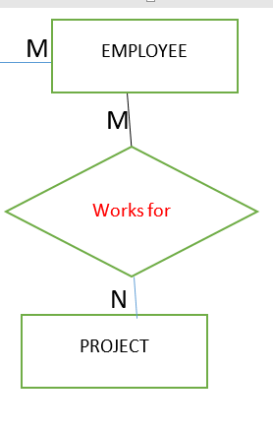

Introduce a new entity between two entities.It has a composite key

EMPLOYEE EMP_PRO PROJECT
EMPNO
PROJECTNO

Student Results
Rego Rego

Rego | name | City
114 | Ann | Kandy
Rego | SAD | BIS
114 | 56 | 85
- Relational Schema

DEPARTMENT (DEPID, DEPNAME, LOCATION)
*
EMPLOYEE- (EMPNO, EMPNAME, EMPADDRESS, TPNO, DOB, DEPID)

* *
EMP_PRO(EMPNO , PROJECTNO , RATE ,DURATION )

PROJECT- (PROJECTNO, PROJECTNAME, BUDGET, DURATION)

